# Prototypes and MVPs for Solar Panel Manufacturing Company

## Prototypes

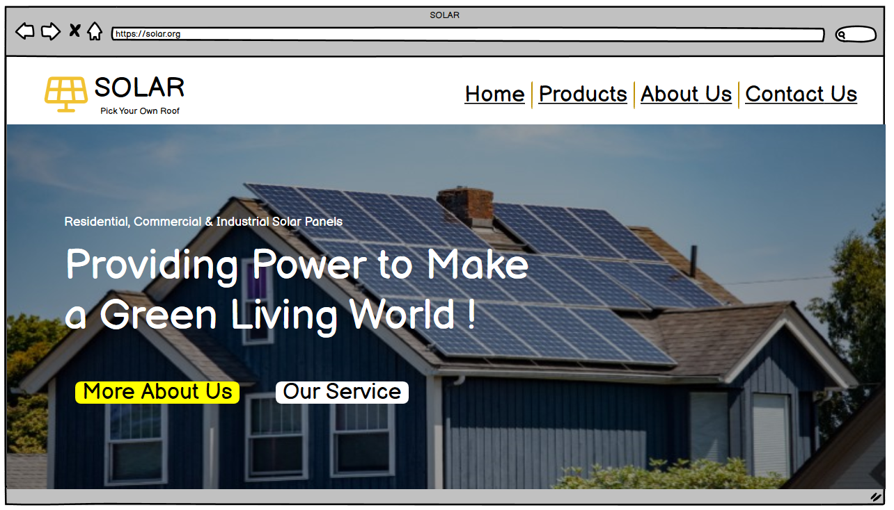

Figure: Home Page

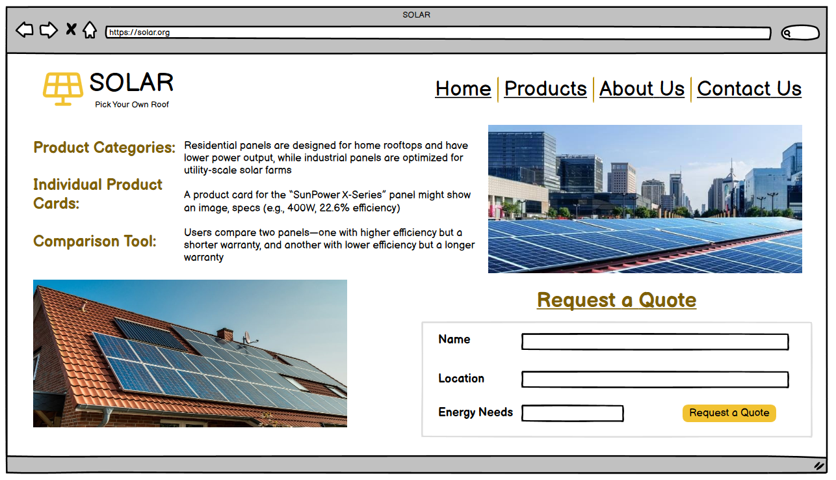

Figure: Products Page

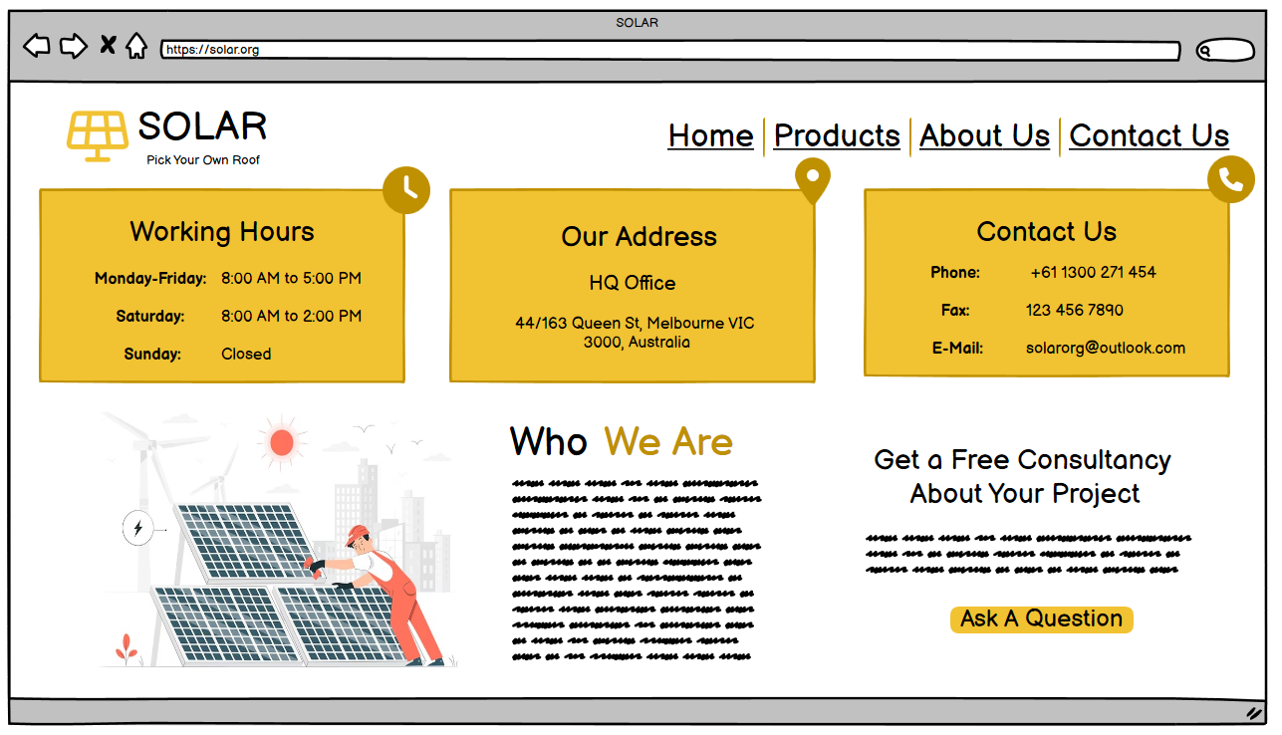

Figure: About Us Page

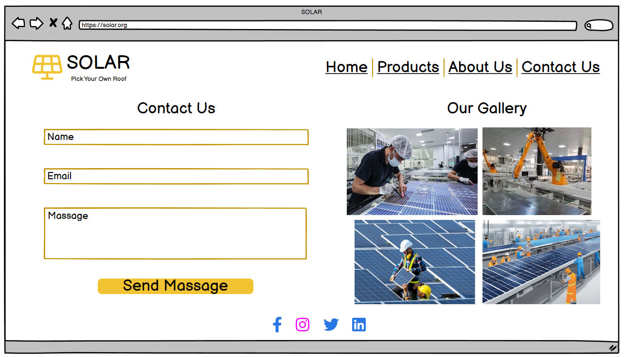

Figure: Contact Us Page

## MVPs

### Introduction

Solar energy is generally known as the most generous renewable energy source, with contemporary technological advancements making solar panels more adequate as well as cost-effective. In Australia at the contemporary time, 1 in 3 households is powered by solar energy, nevertheless, 90% of panels are imported from China. The only domestic manufacturer within Australia completes only 4% of the need. In order to manage global supply chain disruptions and encourage local manufacturing, the Australian government has committed 1 billion AUD for R&D in solar technology.

### MVP Features

The MVP for the solar panel manufacturing company concentrates on leveraging local inventions to construct high-efficiency, cost-effective solar panels. Below is a comprehensive table summarising the fundamental components of the MVP, their descriptions, significance, and anticipated outcomes.

|  |  |  |  |
| --- | --- | --- | --- |
| **Feature** | **Description** | **Importance** | **Expected Outcome** |
| Cost-Efficient Production Methods | Execute advanced manufacturing processes | High | Competitive pricing, lessened prices |
| Flexible Payment Alternatives | Propose financing plans and payment flexibility | High | Augmented accessibility and adoption |
| Educational Campaigns | Conduct awareness and educational campaigns | Medium | More increased consumer awareness and adoption rates |
| Sustainability and Recycling | Create recycling programs and encourage a circular economy | Medium | Improved environmental influence and brand reputation |
| Net Metering and Grid Transmission | Encourage association with the grid and support net metering | High | Economic advantages for consumers increased adoption |
| Smart Energy Management Software | Acquire software to optimize energy usage | High | Maximized energy savings and technique efficiency |
| Customer Support and Maintenance | Present consultations, maintenance, and warranties | High | Long-term customer fulfilment and trustworthiness |
| Cost-Effective Storage Solutions | Deliver affordable battery storage options | High | Improved energy independence and value proposition |

# 

### Value Proposition

The MVP seeks to deliver high-quality, inexpensive as well as affordable solar panels with substantial performance warranties and outstanding customer support. It manages necessary subjects like, increased electricity bills, environmental concerns, along dependence on non-renewable energy sources. The company correspondingly deliver maintenance support and strategic partnerships to improve customer satisfaction and guarantee a high return on investment.

# Agile Product Development Model

## Agile Framework Overview

Agile product development is an iterative as well as incremental strategy that highlights flexibility, collaboration, along customer feedback. The procedure is separated into multiple sprints, each lasting 2-4 weeks, providing continuous progress and adaptation depending on user feedback.

* **Sprint Planning**: Describe the objectives and tasks for each sprint.
* **Sprint Execution**: Create and test the features planned for the sprint.
* **Daily Stand-ups**: Straightforward day-to-day meetings to discuss improvement and obstructions.
* **Sprint Review**: Indicate the terminated work to stakeholders and accumulate feedback.
* **Sprint Retrospective**: Contemplate the sprint’s consequences and pinpoint areas for advancement.

### Phase 1: Initial Planning and Setup

* **Product Backlog Creation**: Compile each and every element and task needed for the MVP.
* **Sprint Planning**: Break down the development backlog into effortless tasks and allocate them to team members.

### Phase 2: Iterative Development Cycles (Sprints)

1. **Sprint 1: Core Feature Development**
   * **Goals**: Develop production methods that are cost-efficient, set up adaptable payment alternatives, and instigate educational movements.
   * **Tasks**: Investigate and execute automation in production, membership with economic institutions, and create educational content.
2. **Sprint 2: Prototype Creation**
   * **Goals**: Design an operational website and the beginning level understanding of the smart energy management software.
   * **Tasks**: Design website pages, incorporate product information and develop software components.
3. **Sprint 3: User Testing and Feedback Collection**
   * **Goals**: Recruit premature adopters for testing and accumulate feedback on usability and functionality.
   * **Tasks**: Complete user testing sessions, accumulate and analyze feedback, and determine areas for advancement.
4. **Sprint 4: Iteration and Improvement**
   * **Goals**: Refine the website and software depending on user feedback, improve core features, and resolve problems.
   * **Tasks**: Execute modifications, optimize features, and formulate an exhaustive report on determinations and planned improvements.

### Phase 3: MVP Finalization and Deployment

1. **Final Sprint: Integration and Final Testing**
   * **Goals**: Incorporate all elements into a cohesive MVP, accomplish final testing, and execute final adjustments.
   * **Tasks**: Incorporate all designed components, conduct comprehensive testing, and refine depending on test outcomes.
2. **Launch Preparation**
   * Create a thorough launch plan, incorporating marketing, sales, and support strategies.
   * Train sales and support teams on the MVP’s characteristics and advantages.
3. **MVP Launch**
   * Release the MVP to the market and observe implementation.
   * Gather initial user feedback to navigate additional development.

### Agile Tools and Roles

* **Project Management Software:** Tools such as Jira or Trello to organise the backlog and track the progress of the product.
* **Collaboration Tools:** Platforms such as Slack or Microsoft Teams for team communication.
* **Version Control Systems:** Tools, for example, GitHub in order to manage code and track differences.
* **Product Owner: Goals**: Incorporate all elements into a cohesive MVP, accomplish final testing, and execute final adjustments.
* **Tasks**: Incorporate all designed components, conduct comprehensive testing, and refine depending on test outcomes.
* **Scrum Master:** Encourages the Agile process and removes barriers.
* **Development Team:** Accountable for delivering product increments.

With the help of adopting an Agile product development model, the solar panel manufacturing company can adequately develop as well as refine its MVP. This approach guarantees flexibility, constant advancement, and alignment with market requirements, ultimately partaking in the success of the company and in the competitive solar energy market.